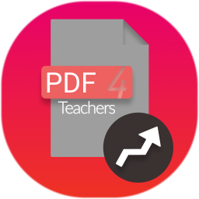
PDF4Teachers
User Manual

Contents :
- Software overview
- Editor functionalities
- Files tab
- Text Elements tab
- Grades / Marking tab
- Shortcuts

1. Software overview

PDF4Teachers is a software dedicated to annotation of learners assessments, in PDF file format. It focuses on maximum productivity in annotating / marking this kind of documents.
PDF4Teachers allows user to quickly add and save recurrent annotations. Edited PDF files can then be exported to generate new PDF files including the edits. When using the grades tool, exporting grades of all documents in CSV file format is made possible.
Il est possible de convertir des images en documents PDF et d’éditer les pages des documents (rotation, position...) avec des boutons situés au pied de chaque page.

This is version 1.2.0, including the following news :

Nouvelles fonctionnalités majeures :
- Conversion d'images en documents PDF
- Édition des pages des documents PDF (rotation déplacement, suppression, ajout...)
- Support du LaTeX dans les éléments textuels
- Implémentation d'un thème sombre

Nouvelles fonctionnalités :
- Le rendu du fichier PDF se fait maintenant en fonction du niveau de zoom
- Possibilité d'ajouter un élément textuel avec un double clic
- Des retours à la ligne sont ajoutés automatiquement aux éléments textuels s'ils sont plus larges que la page.
- Les notes nommées "Bonus" ne sont plus compté dans le total du barème.
- Possibilité d'ouvrir la console d'exécution avec Ctrl+Alt+C
- Les éditions et données utilisateur sont maintenant enregistrés au format YAML

Correction de bugs :
- Dans les menu contextuels : le clic est maintenant détecté partout.
- Support des images au format Jpeg2000 (C.f #30 )
2. Edit functions
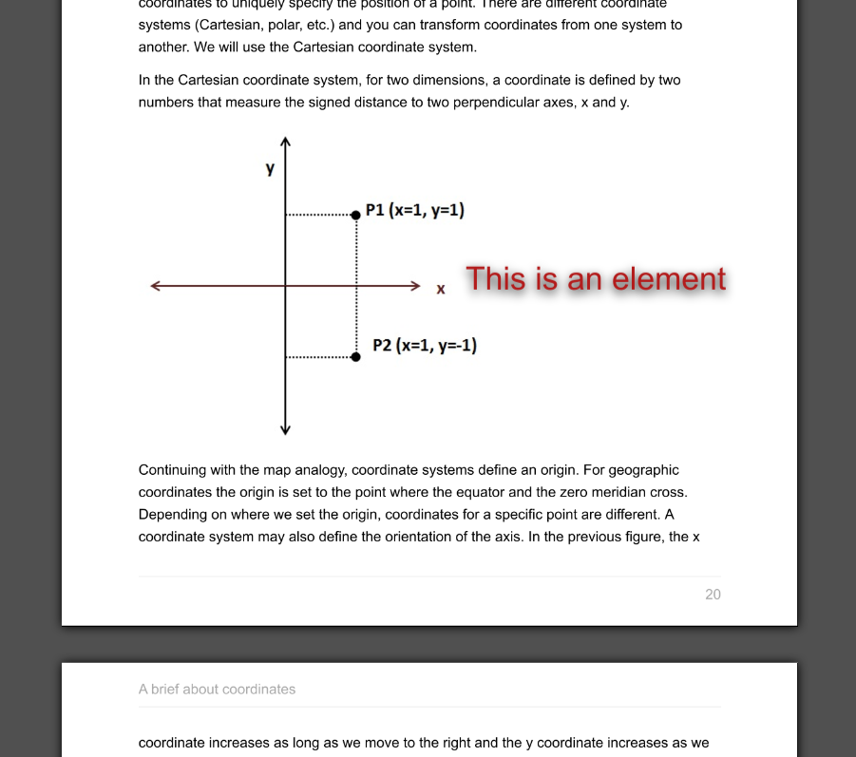
Various elements can be added on the document (text, grades, drawings). These elements constitute the edit of the document. (stored in \AppData\Roaming\PDF4Teachers\editions for Windows10 and in ~/.PDF4Teachers /editions/ for MacOSX and Linux).

Left side figure shows a text element. Elements can be moved and edited in the left panel tabs of PDF4Teachers.

Document edit is loaded as an overlay every time the document is opened in the main panel, but the PDF file is not modified.

Once editing is finished, document should be exported, in order to create a new PDF file, on which the whole edit will be permanently added (File → Export).
3. Files Tab

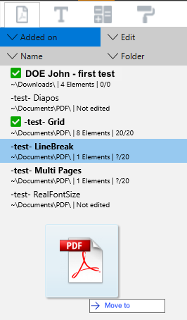
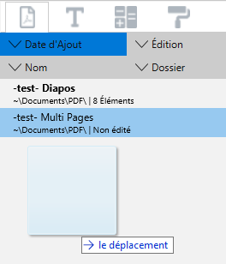
Left panel includes 4 tabs. First tab (showed on the left side figure) lists all the opened documents, ready to be edited.

This tab purpose is to give a very quick access to all files from a same folder (typically a folder containing all the PDFs of one assessment), with File → open folder.

It is then possible to edit files (double clic) or various actions (context clic)

Drag and drop of a file or a folder is also possible

File sorting in the tab can be set through the top buttons of the tab.
4. Text elements tab

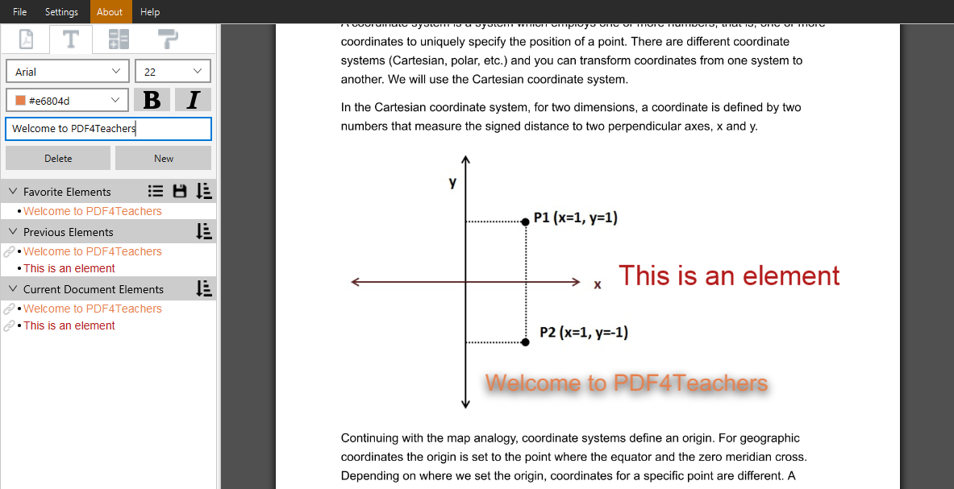
Creating a new text element is done by a clic on new. Text is written in the form field of the tab. The element displays on the left side of the sheet.
The height of the insertion point is determined by the last flyover of the mouse pointer when leaving the sheet to the left panel. Anticipating this behavior will help you placing immediately the element at the correct height on the sheet.
Il est aussi possible d’ajouter un élément textuel avec un double clic sur la page ou avec le raccourcis [OS]+T.
Si l’élément est trop large pour la page, il ajoute des retours à la ligne automatiquement. Il est possible de supprimer tous les retours à la ligne inutiles avec le menu contextuel du champ d’entrée.

Categories Favorite elements, Previous elements, Current document elements allow a quick access to already inserted text elements. A clic inserts on the sheet, and a context clic on a listed element, on a category, or on an element inserted on the sheet gives access to the context menu, with various shortcut functions.
Help bubbles will popup with more detailed information when leaving the pointer device over buttons or interface elements.

Icon allows to save the content of the favorites list. Thus, favorites can be organized and loaded for future corrections of similar assessments.
Icon gives access to previously saved favorites elements. Loading or deleting is possible. After loading, modifications in the list will not affect the saved list. To modify a saved list, a new one must be created, with the same name.
Icon  sets the sorting options of the listing.

Previous Elements : Each new element is added in the Previous Elements list. This list stores the only the 50 last inserted text elements. List can be flushed through context menu, on the category. When an element shows up in Previous Elements, it is linked to the sheet element that was just created. The link symbol  means that any further modification of the specific element on the sheet will update the element in the list. It can be unlinked through the context menu.

Current Document Elements : Displays all the elements present on the current document.

Favorite Elements : Adding to Favorite Elements is done through the context menu on elements present in others lists or in the sheet. When done from a list, default behavior will move the element from the list to the Favorite Elements list. In order to have a copy behavior, a setting can be done in the Settings menu.

5. Grades tab
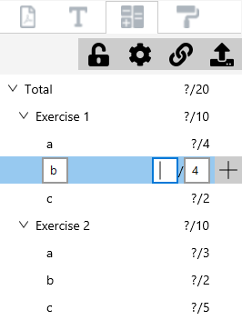
The 4 buttons on top of the tab have info-bubbles detailing their use when leaving the pointer device on it.

This Tab potentially allows the user to enter a grade scale (marking scheme) while correcting the first document of a set. Same tool allows to enter grades. Grade scale can then be copied on other documents thanks to the button . Of course only the scale will be copied, not the grades. In case a grade scale already exists in the destination files, merging options will be displayed.

At anytime, all the grades of a set of documents (or of a single document) can be exported to a spreadsheet file in .csv format with the button .

Grades and grading scale are managed through a hierarchical scheme. This allows to add automatically grades of an exercise to show the exercise sum, and to add automatically the grades of each exercise to a total. A maximum of 4 levels + total is possible. Display options are set with .

Add of a new grade in the grade scale is done with the button which will add a grade of a lower hierarchical level : a clic on the button showed on the above figure would create a sub-grade in the b question of the exercise 1.

Unentered grades are not visible on the sheet, they will show up at the last position of the pointing device once entered. Unentered grades count for 0 in the sum.

Il est possible de nommer une note « Bonus » pour que son total ne soit pas compté dans le
total du barème.
6. Shortcuts

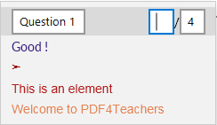
Context menu on the sheet gives access to entering the next grade (if a grading scale is defined in the grades tab), at the exact position of the mouse pointer. It also shows the 6 most used text elements.

Several actions can be accessed through keyboard shortcuts. Some are mentioned in the interface. Below is a list of bonus useful shortcuts. [OS] means [ctrl] key on PC keyboards and [cmd] key on Mac keyboards

- [OS]+T : Creates a new empty text element at the position of the pointer.
- [OS]+N : Selects the next grade field to enter and will place the grade at the pointer position.
- [OS]+[1-9] : Adds the corresponding favorite text element at the pointer position.

- [OS]+Alt+[1-9] : Quick load of a saved favorites list (alphabetical sorting between the 9 first lists).
- [OS]+Alt+0 : Saves the current favorites list to a new saved list.
- [OS]+Alt+C : Ouvre la console d’exécution de l’application (Utilisateurs expérimentés)

Depending on the keyboard configuration, pressing [shift] key may be necessary to access shortcuts using numbers.

